

**Portfolio 1 (P1)**

Year 1 (2018/19), Semester 2

## SCHOOL OF INFOCOMM TECHNOLOGY

Diploma in Information Technology

**Continuous Assessment 1(CA1)**

**Weightage:** 20% of module

**Individual/Team/Both:** Individual

**Format:** Profile updating at ICT’s ePortfolio portal (25%)

Development Blog (75%)

**Penalty for late submission:**

* + 10% per day.

There are a total of 10 pages (including this page) in this handout.

|  |
| --- |
| ***WARNING***  ***If a student is found to have submitted work not done by him/her, he/she will not be awarded any marks for this assessment. Disciplinary action will also be taken.***  ***Similar action will be taken for the student who allows other student(s) to copy his/her work.*** |

**1. OBJECTIVE**

This continuous assessment requires the student to build up his personal portfolio page in ICT’s ePortfolio portal, <http://eportfolio.ict.np.edu.sg/2018/> . A development blog also needs to be setup, and the student is required to provide weekly updates on the development of his/her portfolio project during the second half of the semester.

**2. SUBMISSION DEADLINES**

Update of personal profile page (2 Nov 2018)

Setup of development blog (30 Nov 2018)

* Weekly updates of development blog from week 8 (3 Dec 2018) onwards

**3. SCOPE AND DELIVERABLES**

1. Personal Portfolio Page

* The following items must be uploaded and posted in your personal profile page
  + Professional profile picture
  + Update of profile write-up
  + Images of at least 2 artefacts of work done in up to this point in time. These may include Year 1 assignments and work done outside of NP.
* The ICT ePortfolio portal is located at <http://eportfolio.ict.np.edu.sg/2018/>
* Instructions on how to upload content into your personal portfolio page can be found in the Appendix below.

1. Development Blog

* You may use any online platform to develop your development blog. For example,
  + Wordpress
  + Blogger
  + Wix
  + …etc
* From week 8 onwards, you are required to update your blog, on a weekly basis, on the development of your assignment.
* Every week, half an hour of your practical session will be set aside for you to update your development blog.

**Appendix**

**Login**

1. Open <http://eportfolio.ict.np.edu.sg/2018/site/login>.
2. Login ID is the same as the student number on the student card, e.g. 11111111W (with Ref char)
3. Password is “password” (lower case).
4. Do change your password after you have logged in.

**Features for the Student Account**

### Edit Profile

1. Update the respective fields as required.

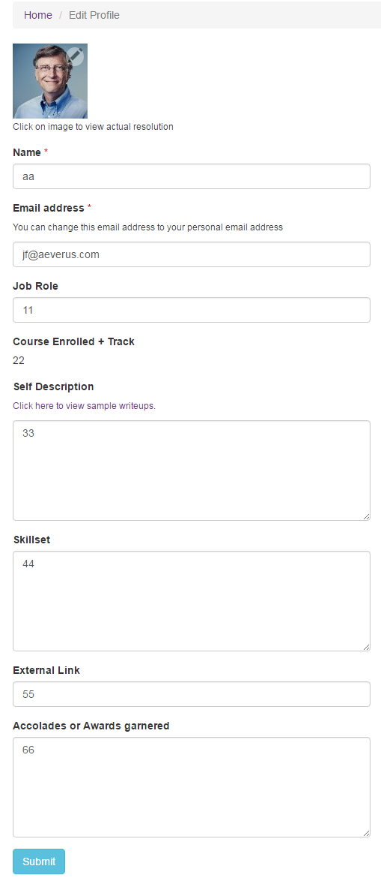

1. To update the profile image, click on the pencil icon.



1. Select the profile image and click ‘Upload’.

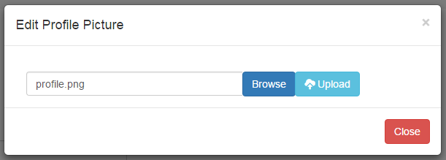

1. Upon successful upload, you will see a notification on the dashboard.

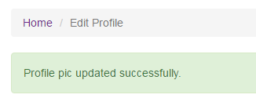

### Change Password

1. Enter the current and new password that you will be using.

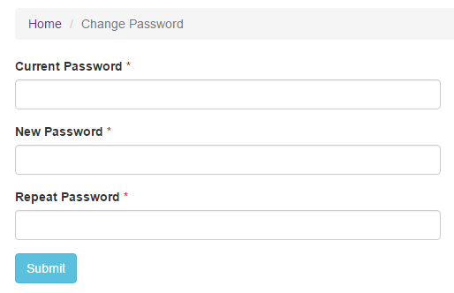

1. Upon successful change, you will see a notification on the dashboard.

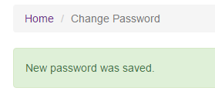

### Personal Works - Add

1. Click on the Add Project button to create new personal work.

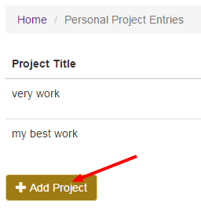

1. Update the respective fields as required.

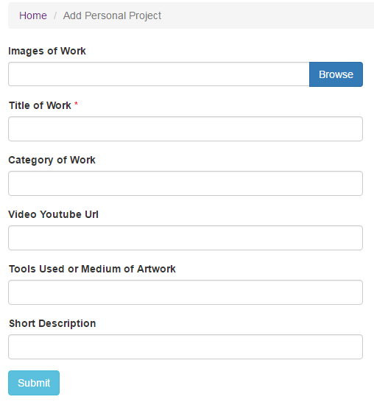

1. Click on the Browse button to upload images. You can upload multiple images.

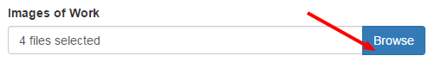

1. Upon successful creation, you will see a notification and new project entry on the dashboard.

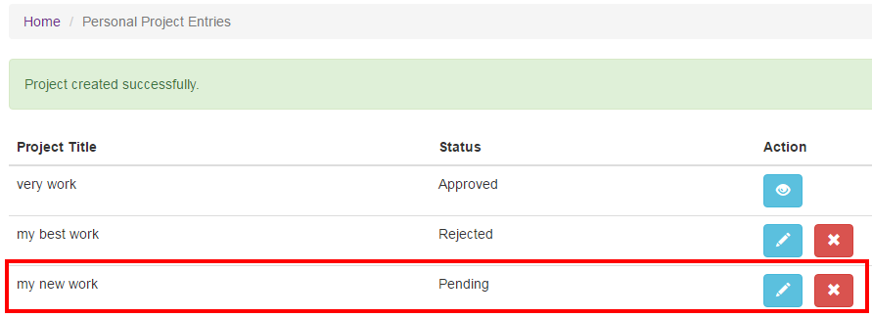Personal Works – Edit

1. Click on the pencil icon to edit a personal work.



1. Update the respective fields as required.

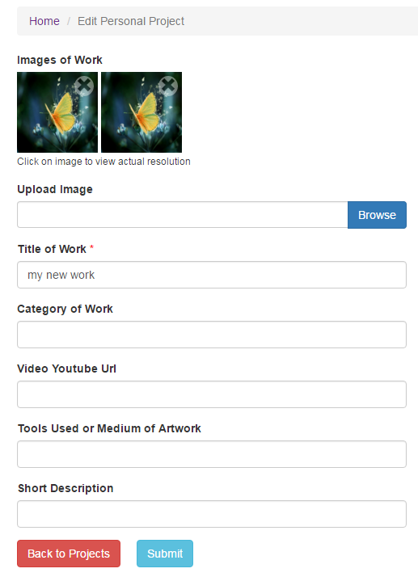

Note: For every image and video that you will be uploading, please make sure that the name of the files are unique. Do not upload 2 different images with the same filename.

1. To delete an image, click on the X icon on the image.

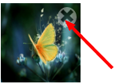

1. Confirm the deletion of the image.

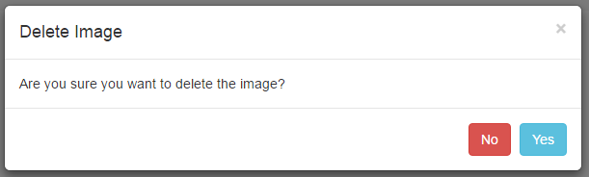

1. Upon successful deletion, you will see a notification on the dashboard.

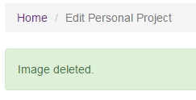

1. Click on the Browse button to upload images. You can upload multiple images.

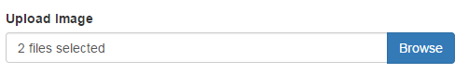

1. Click Submit to update the personal work.

C:\Users\Owner\Desktop\7.png

1. Upon successful update, you will see a notification on the dashboard.

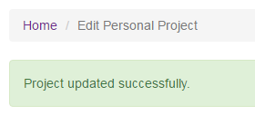

Personal Works – Delete

1. To delete a personal work, click on the X icon.

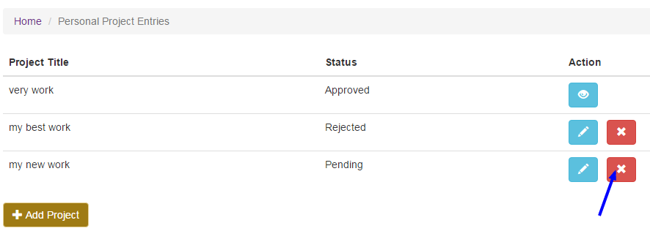

1. Confirm the deletion of the personal work.

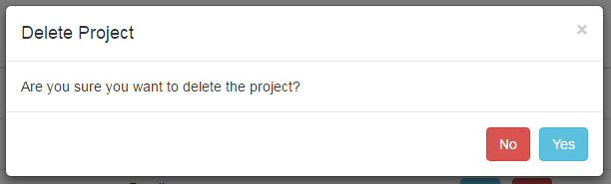

1. Upon successful deletion, you will see a notification on the dashboard.

